*OT-One: Parts and Accessory List*

**

*Written by Opentrons*

*Updated this week*

## ***This article is about the OT-One.***

## ***It's no-longer sold or actively supported by Opentrons, but we've kept this article here to help existing users. Please*** [***see our OT-2 Support articles***](https://support.opentrons.com/) ***for the most up to date information!***

*Summary: This document shows all the parts and accessories included in all robot orders. These parts are spare parts for your robot for common maintenance and repair. The accessories can be used to attach labware to the robot, including pipettes and pipette tip boxes.*

*If you have any questions on usage of the parts and accessories, please do not hesitate to contact us via* [*Opentrons Support*](https://support.opentrons.com/opentrons-account-and-support/what-is-opentrons-support)*.*

# *List of all included parts and accessories:*

*The parts and accessories included are as follows:*

* *2 TipOne tip box adapters*
* *Extra set of* [*pipette clips*](https://github.com/OpenTrons/otone_hardware/blob/master/models/126_S1.stl) *with drop tip*
* *1 12V 10A Power Supply*
* *1 AB Cable*
* *8/10mm Wrench*
* *Allen Key set*
* *1 Tube of white lithium grease*
* *Extra Home Switches*
* *Extra Hardware (3D printed & screws)*

*Image of all included parts and accessories*

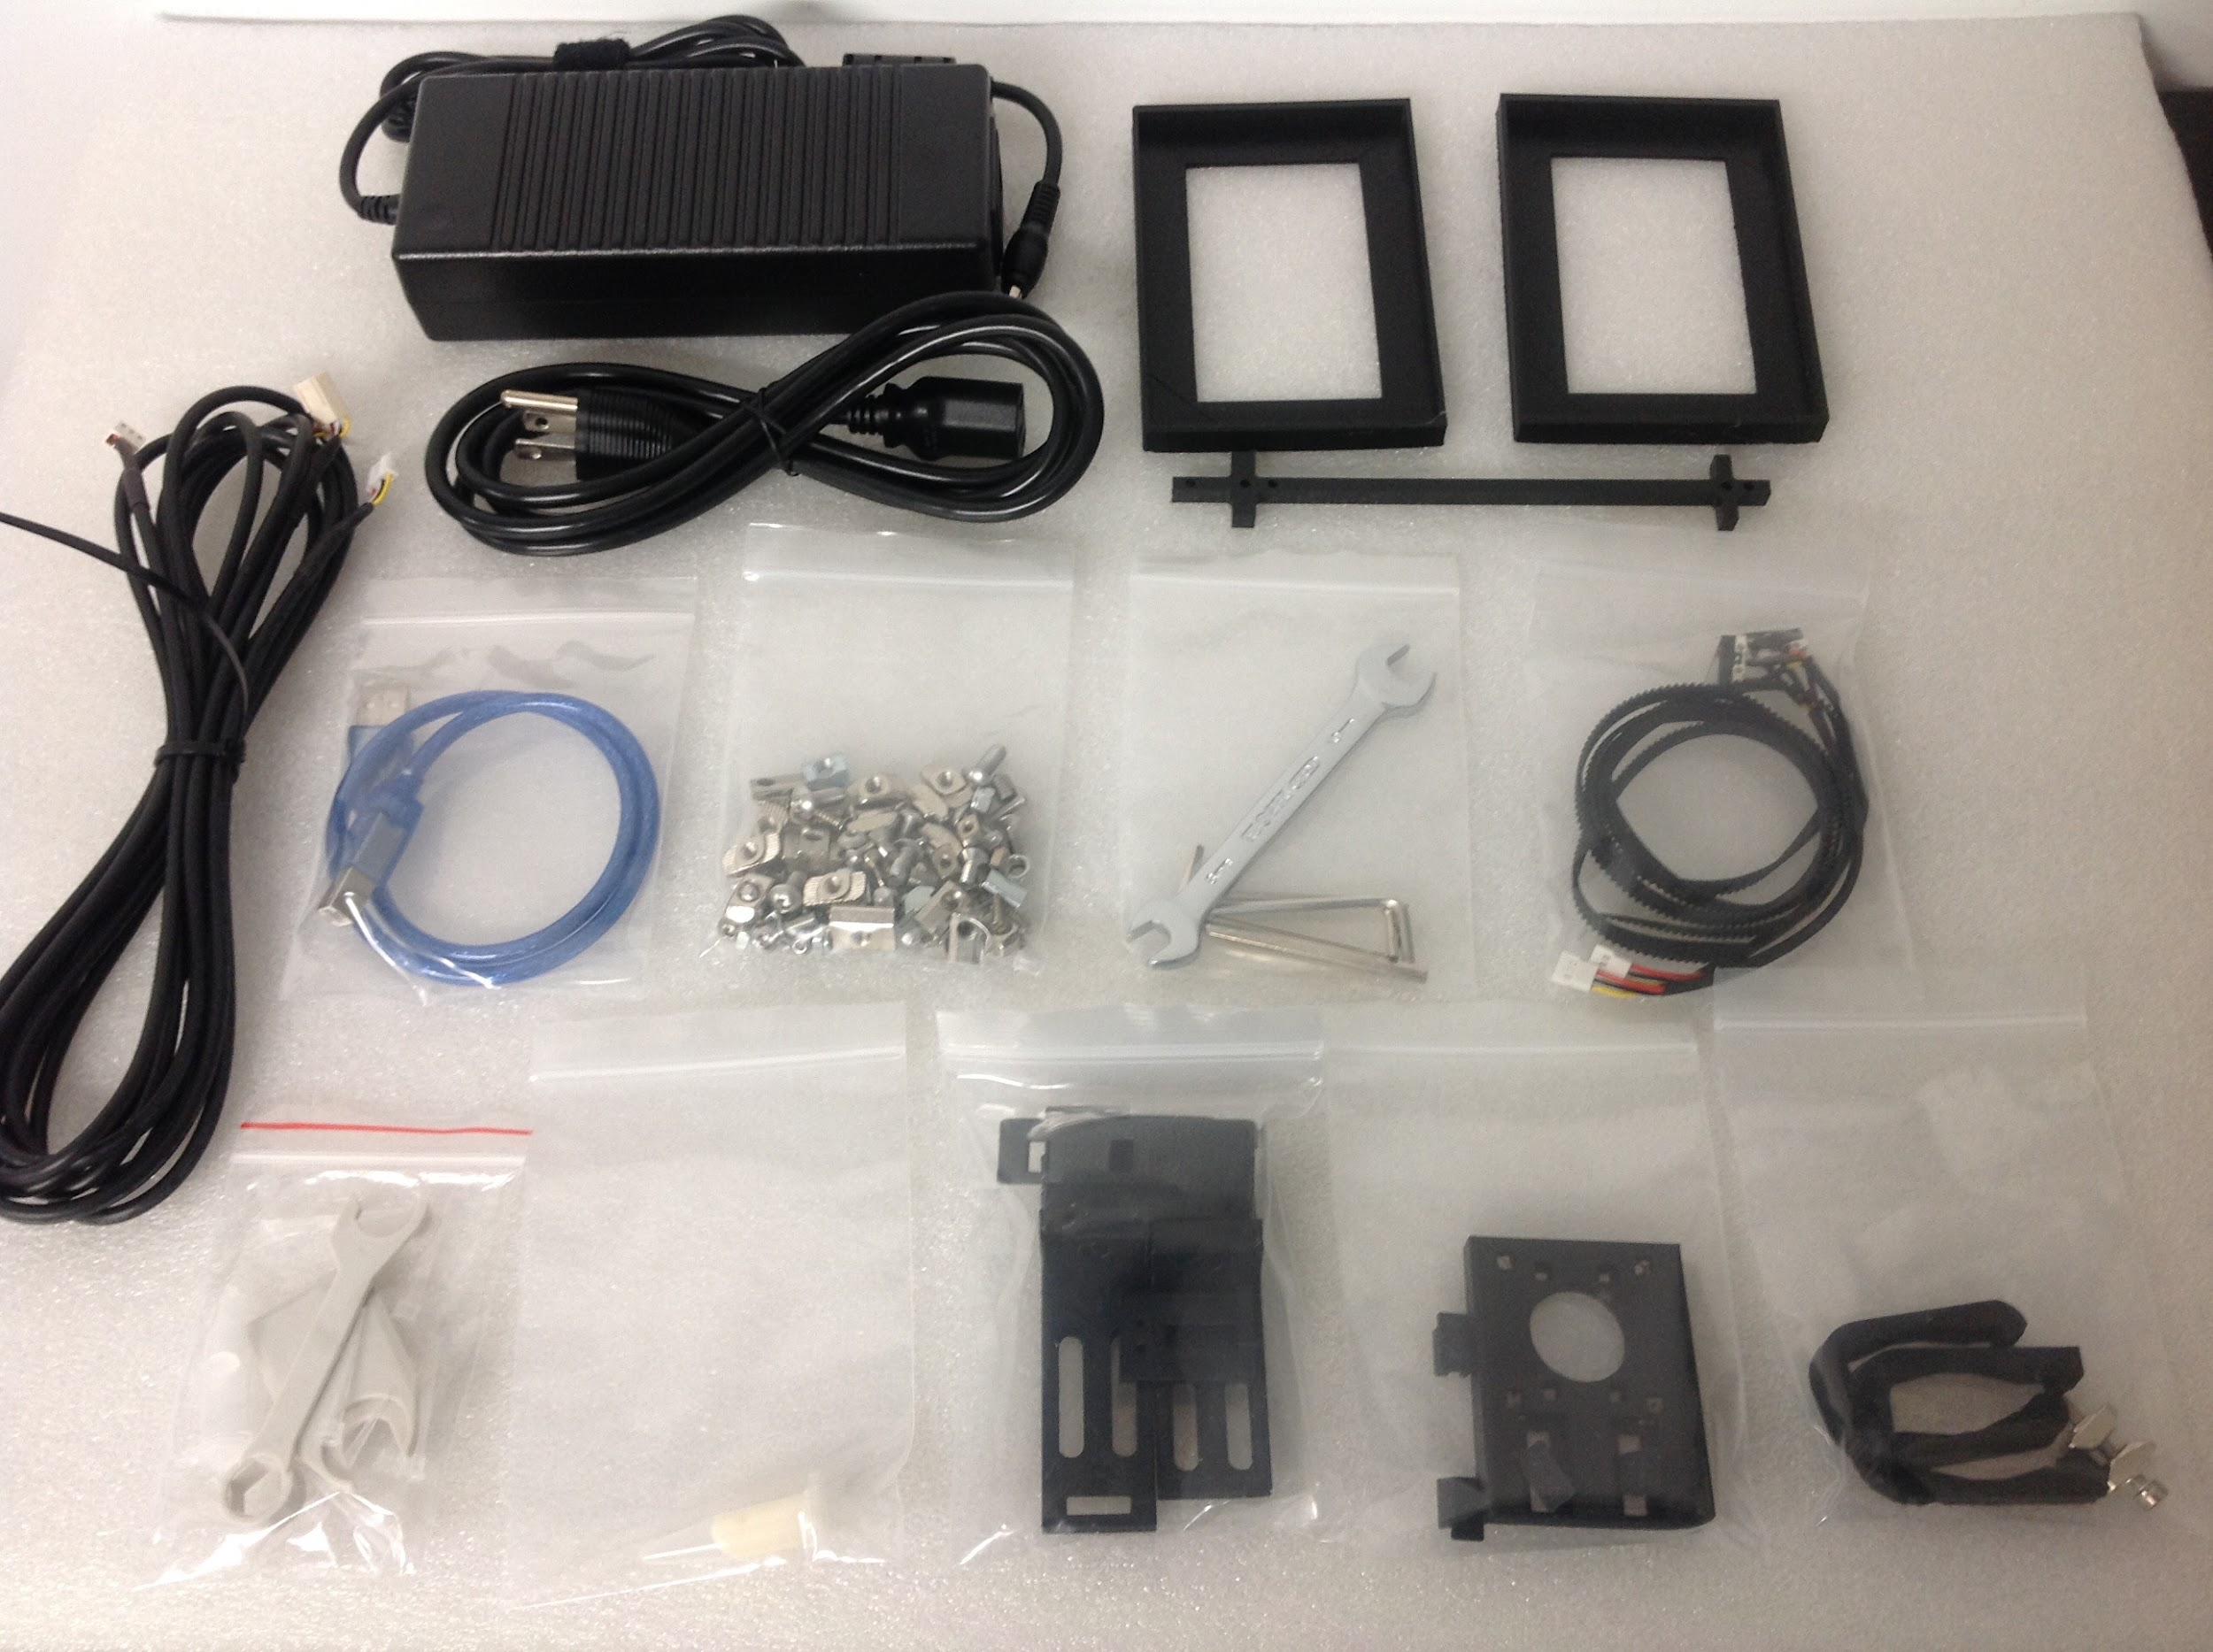

# 

# *Links to 3D printable hardware*

*-*[*Dragonlab pipette clips*](https://github.com/OpenTrons/otone_hardware/blob/master/models/126_S1.stl)

*-*[*DragonLab Multichannel Pipette Stabilizer*](https://github.com/OpenTrons/otone_hardware/blob/master/models/DragonLab%20Multichannel%20Pipette%20Stabilizer.stl)

*-*[*Y Home switch plate*](https://github.com/OpenTrons/otone_hardware/blob/master/models/100%20-%20Y-home%20switch.stl)

*-*[*Z motor mount*](https://github.com/OpenTrons/otone_hardware/blob/master/models/Z-Motor%20Mount%20V1.2.STL)

*-*[*Z Home switch plate*](https://github.com/OpenTrons/otone_hardware/blob/master/models/Z-Home%20Switch%20V1.3.STL)

*-*[*OT-Hood motor controller box stabilizer*](https://github.com/OpenTrons/otone_hardware/blob/master/models/Hood%20OTMC%20box%20lock.stl)

*-*[*Home switch plate (X, A, B)*](https://github.com/OpenTrons/otone_hardware/blob/master/models/Home%20switch(X%2CA%2CB).stl)

*-*[*Switch Clip Holder*](https://github.com/OpenTrons/otone_hardware/blob/master/models/ClipHolder.STL)

*-*[*Pipette Stopper L bracket*](https://github.com/OpenTrons/otone_hardware/blob/master/models/Pipette%20stopper%20(Left%20%26%20Center).STL)

*-*[*TipOne tip box adapter 10uL & 300uL*](https://github.com/OpenTrons/otone_hardware/blob/master/models/TipOne%20tip%20rack.stl)

*-*[*TipOne tip box adapter 1000uL*](https://github.com/OpenTrons/otone_hardware/blob/master/models/TipOne%20tip%20tack%20for%201mL.STL)

*-*[*Belt Clip Hardware*](https://github.com/OpenTrons/otone_hardware/blob/master/models/1100_F_Belt_Clip.stl)

*-*[*Camera Mount*](https://github.com/OpenTrons/otone_hardware/blob/master/models/Camera%20Mount.STL)

*-*[*Wire holder Insert*](https://github.com/OpenTrons/otone_hardware/blob/master/models/HomeSwitchCableClip.stl)

*-*[*X rail bracket (left)*](https://github.com/OpenTrons/otone_hardware/blob/master/models/X-Rail%20Bracket.stl)

*-*[*X rail bracket (right)*](https://github.com/OpenTrons/otone_hardware/blob/master/models/X-Rail%20With%20Y-Cable%20Slot.stl)

# *Accessories*

*Two TipOne tip box adapters*

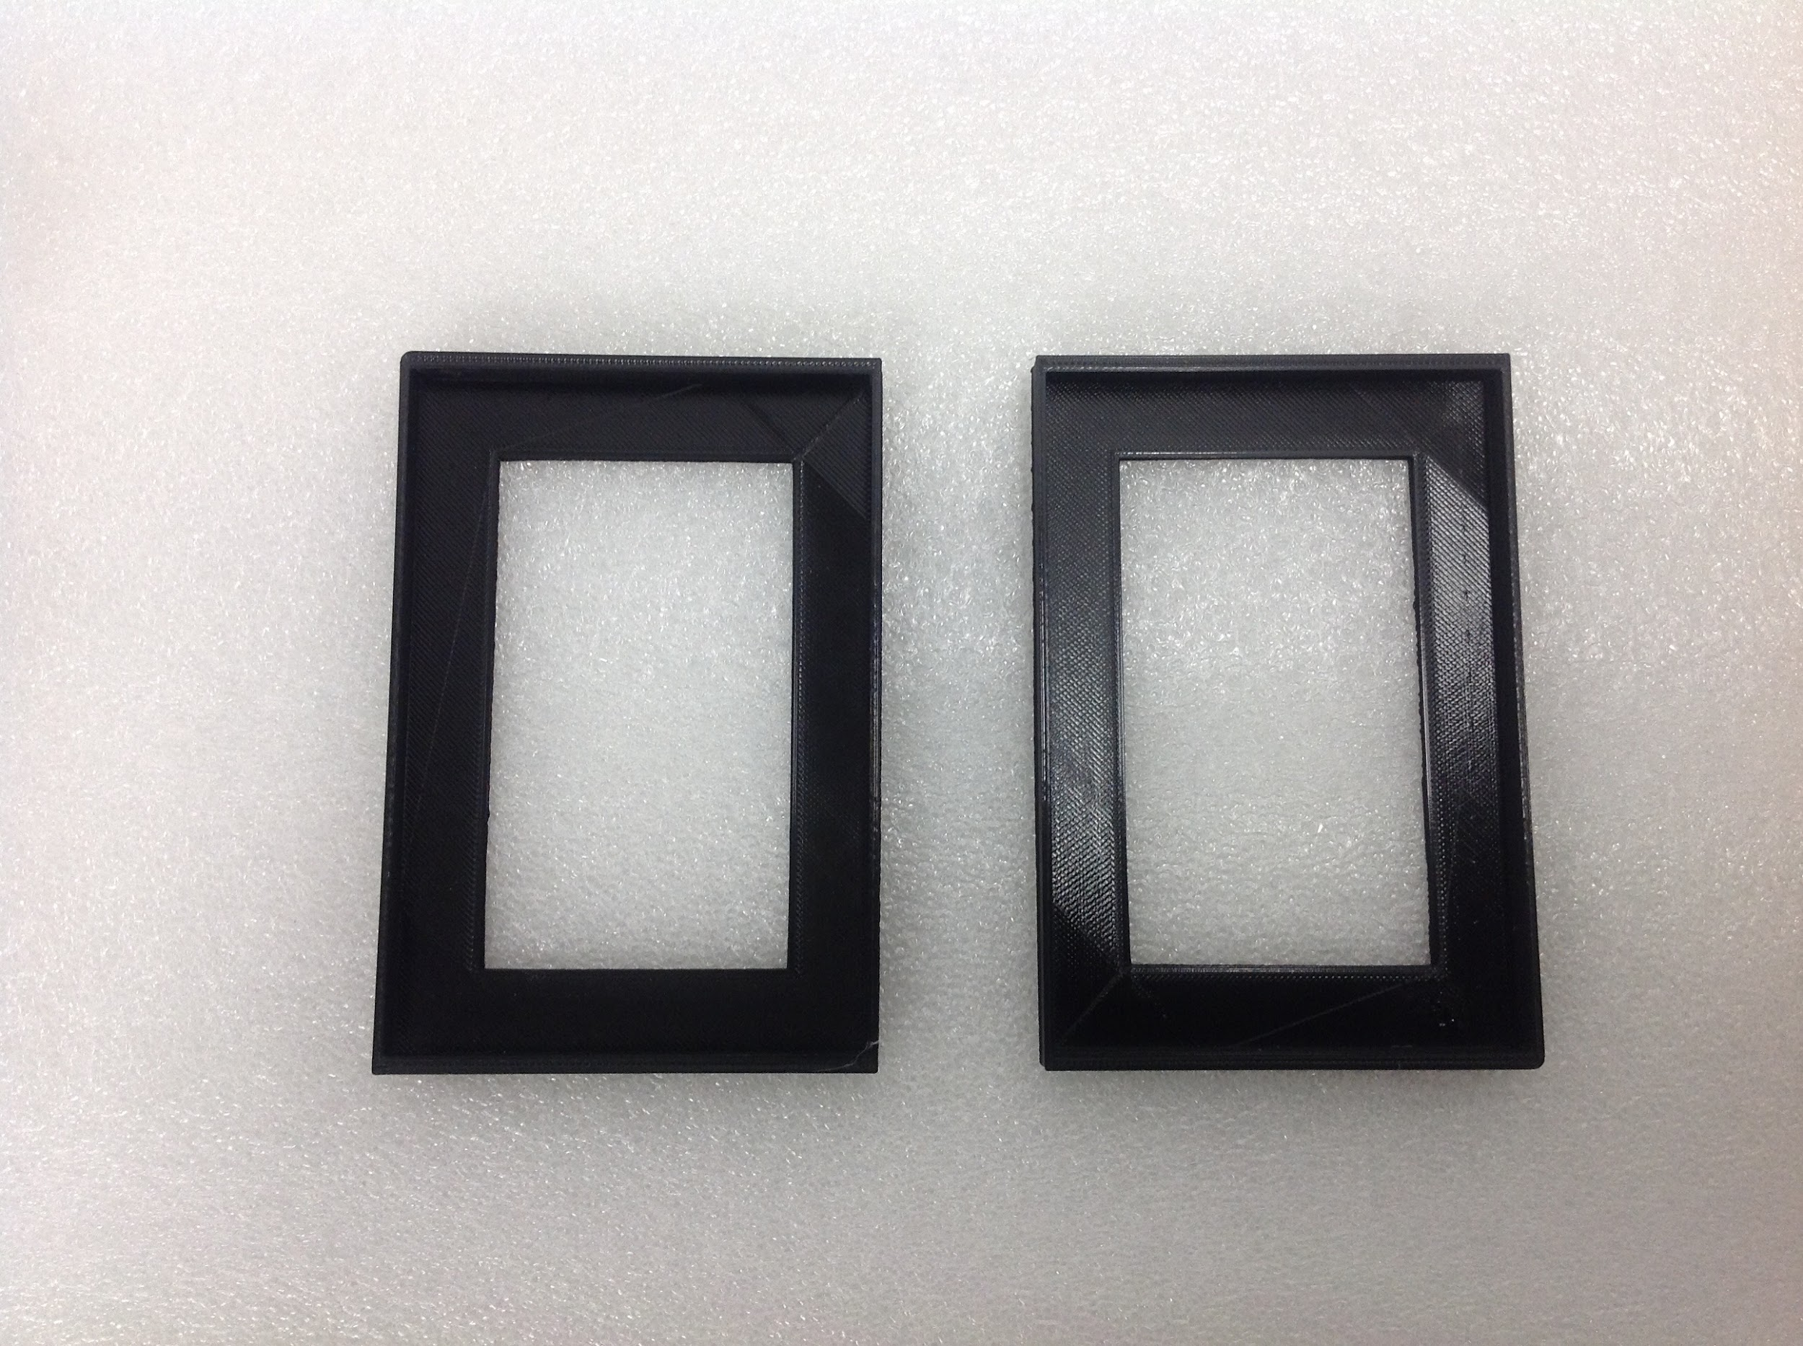

*These adapters fit 10uL & 300uL tip boxes **tip boxes not included*

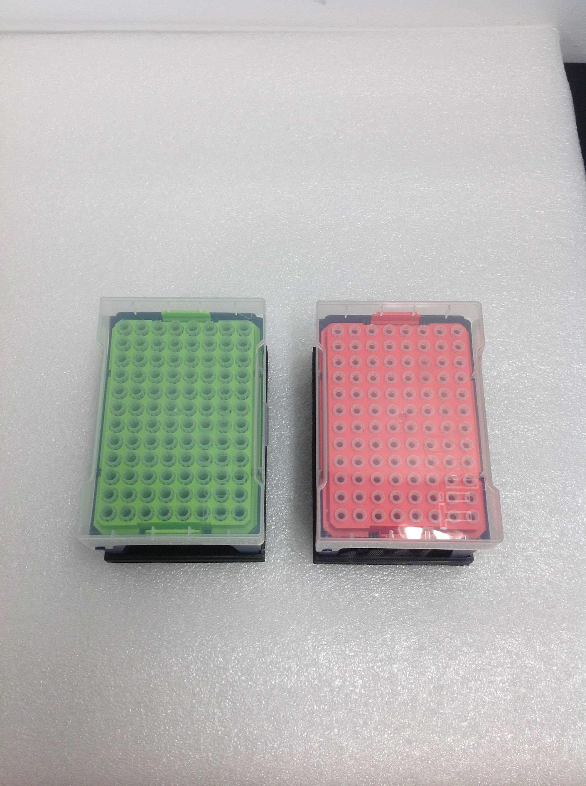

*Extra set of pipette clips with drop tip*

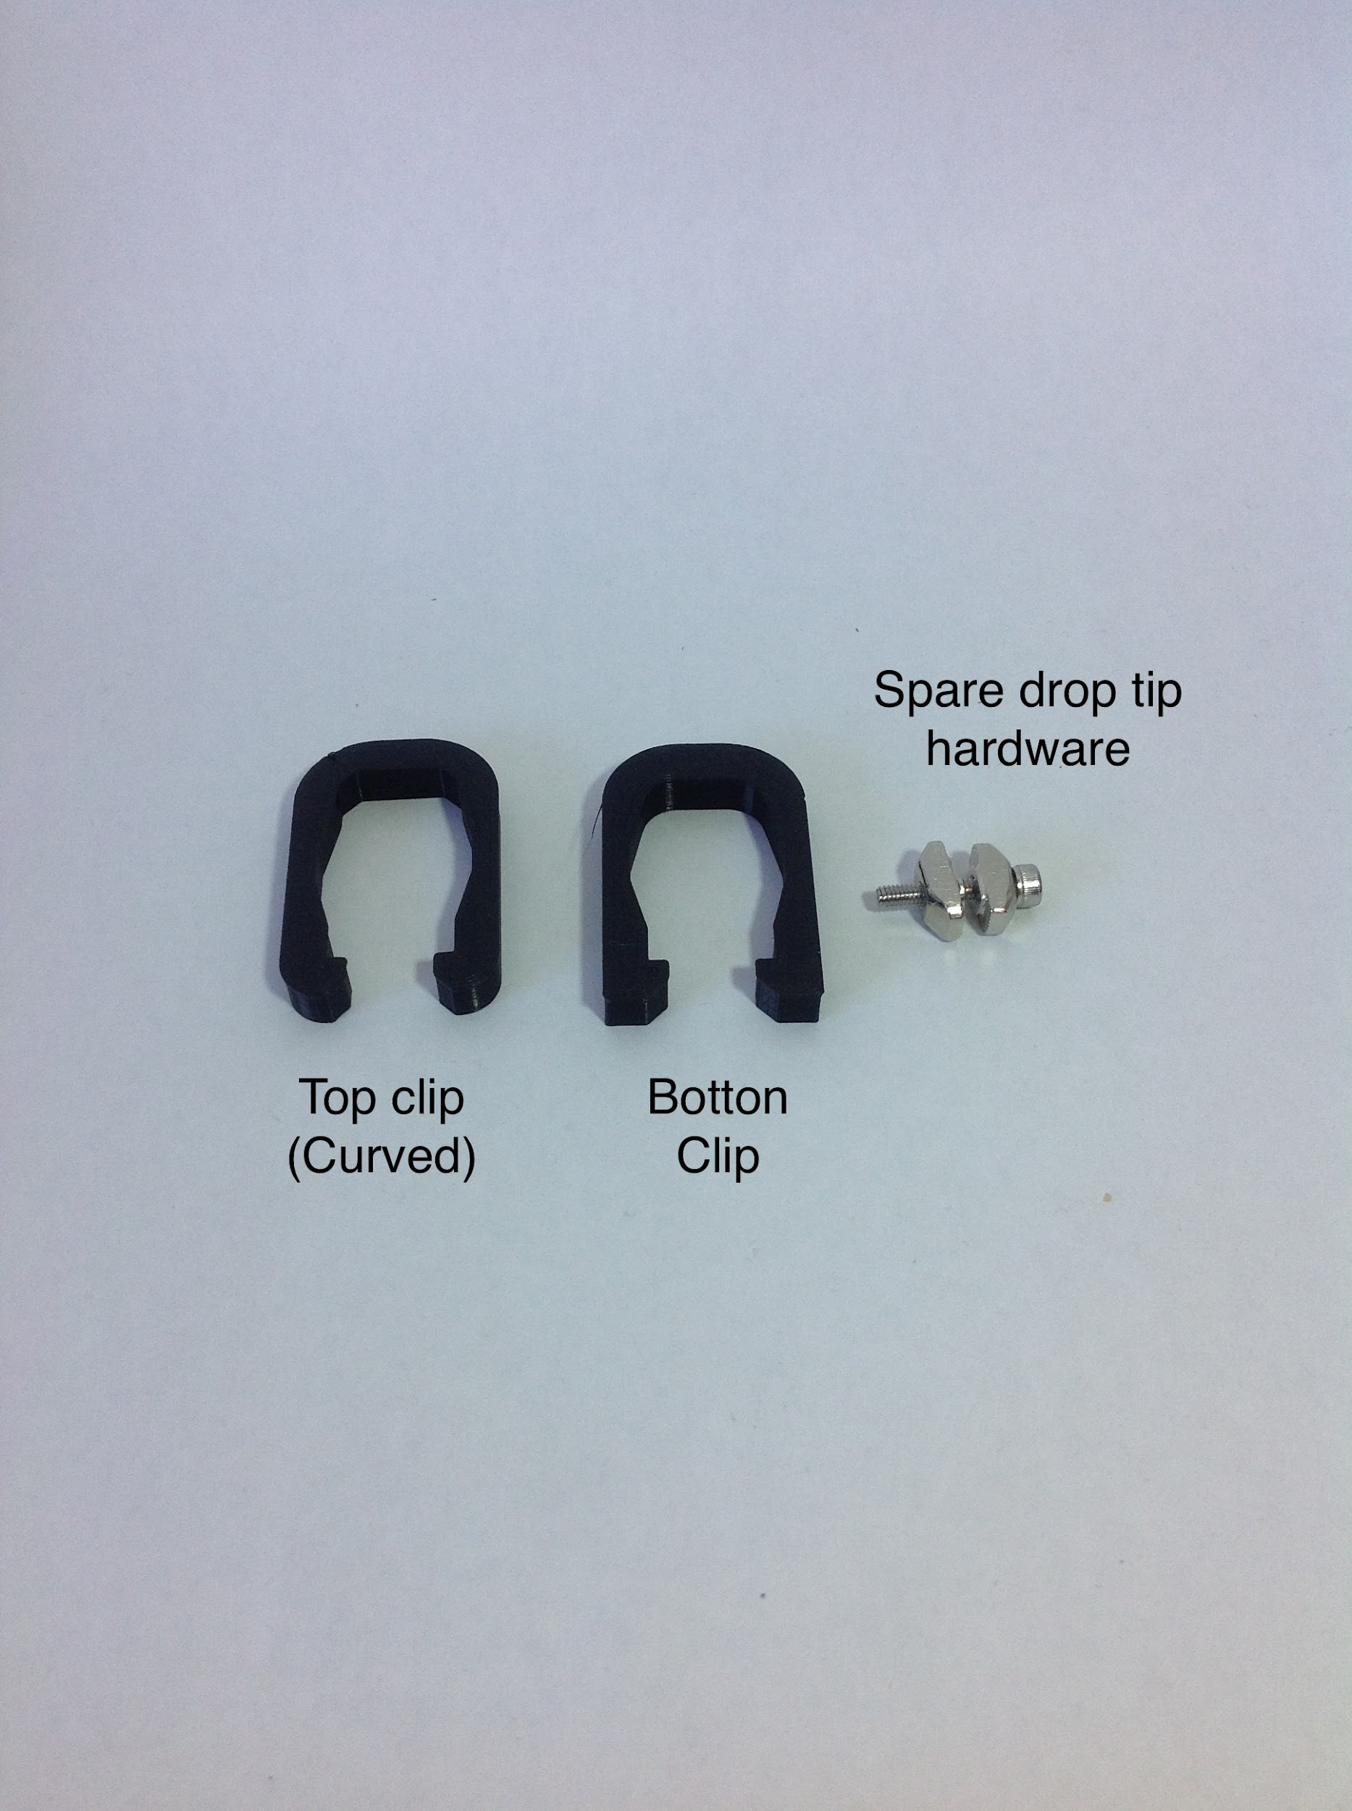

*12 Volt 10 Amp power supply*

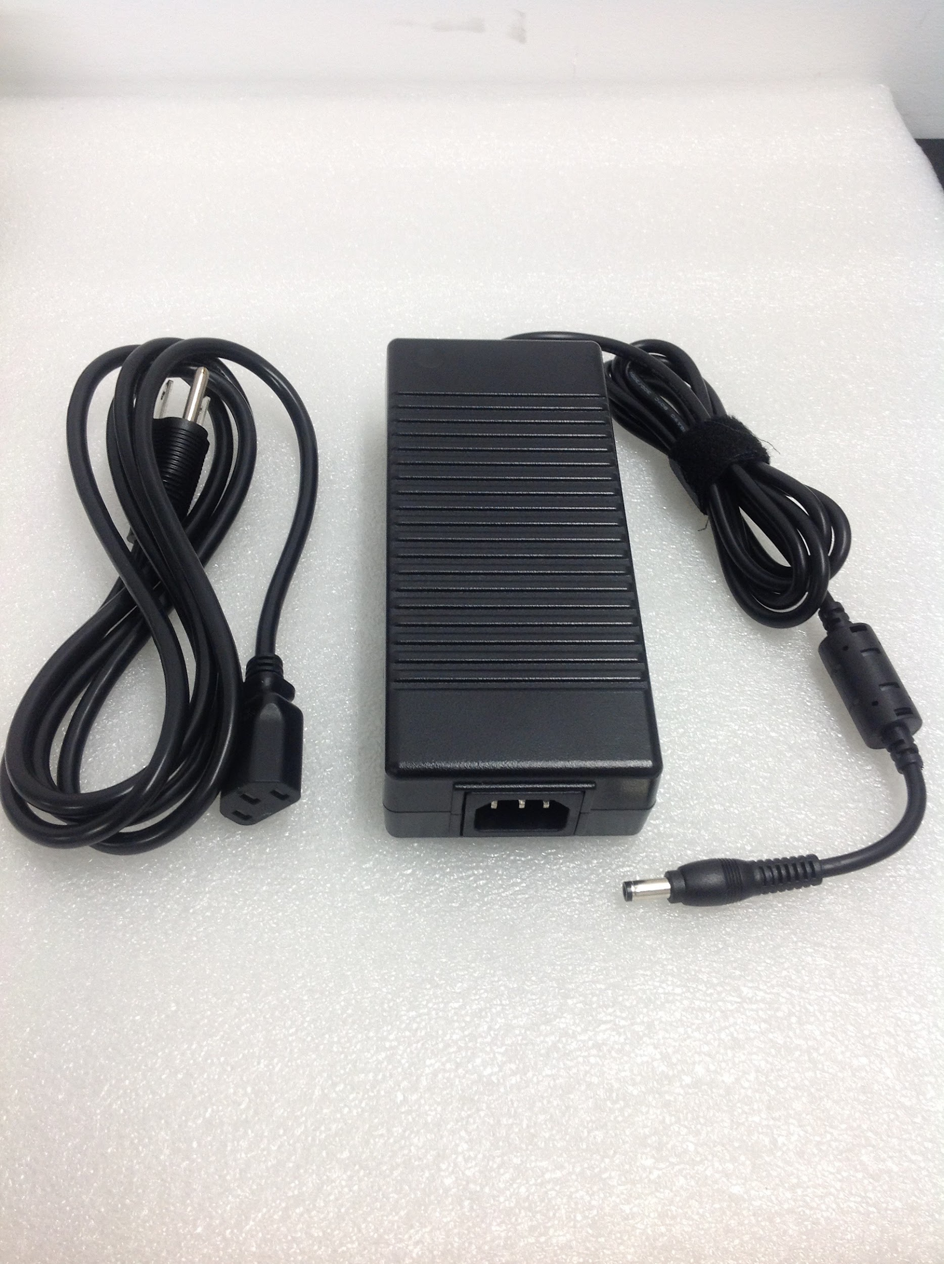

# *Parts*

*Spare nuts and bolts*

*Collection of the primary nuts and bolts used on the OT-One*

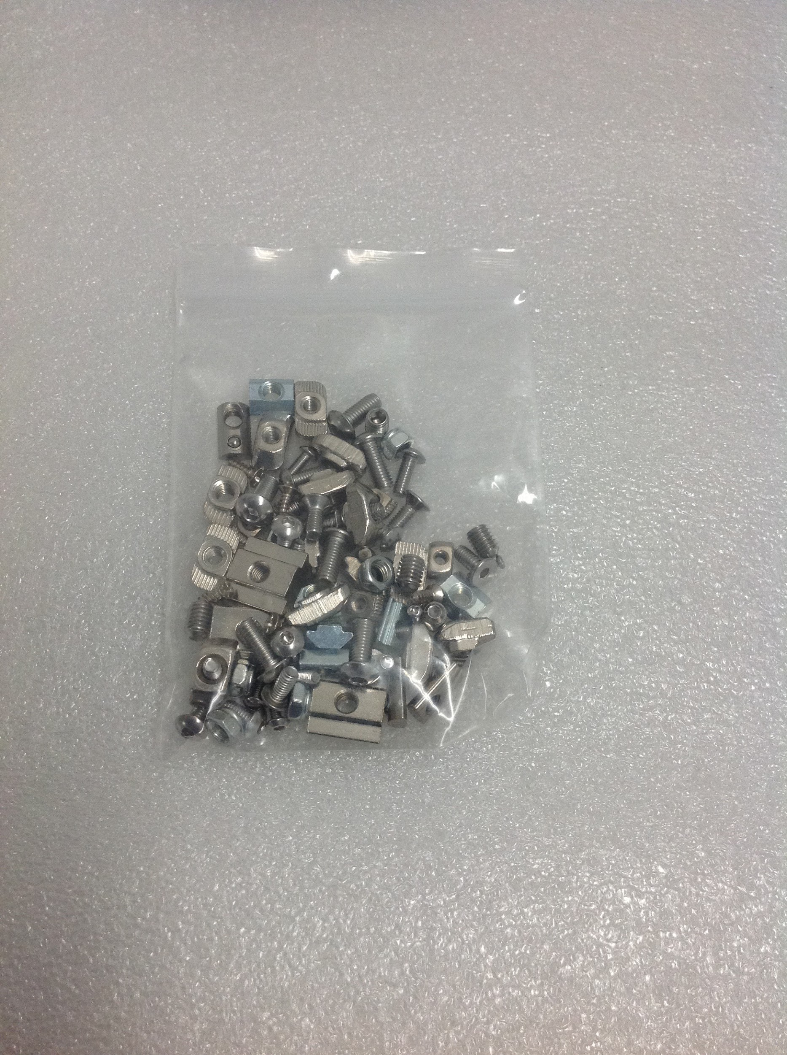

*2 Home Switches and Belt track*

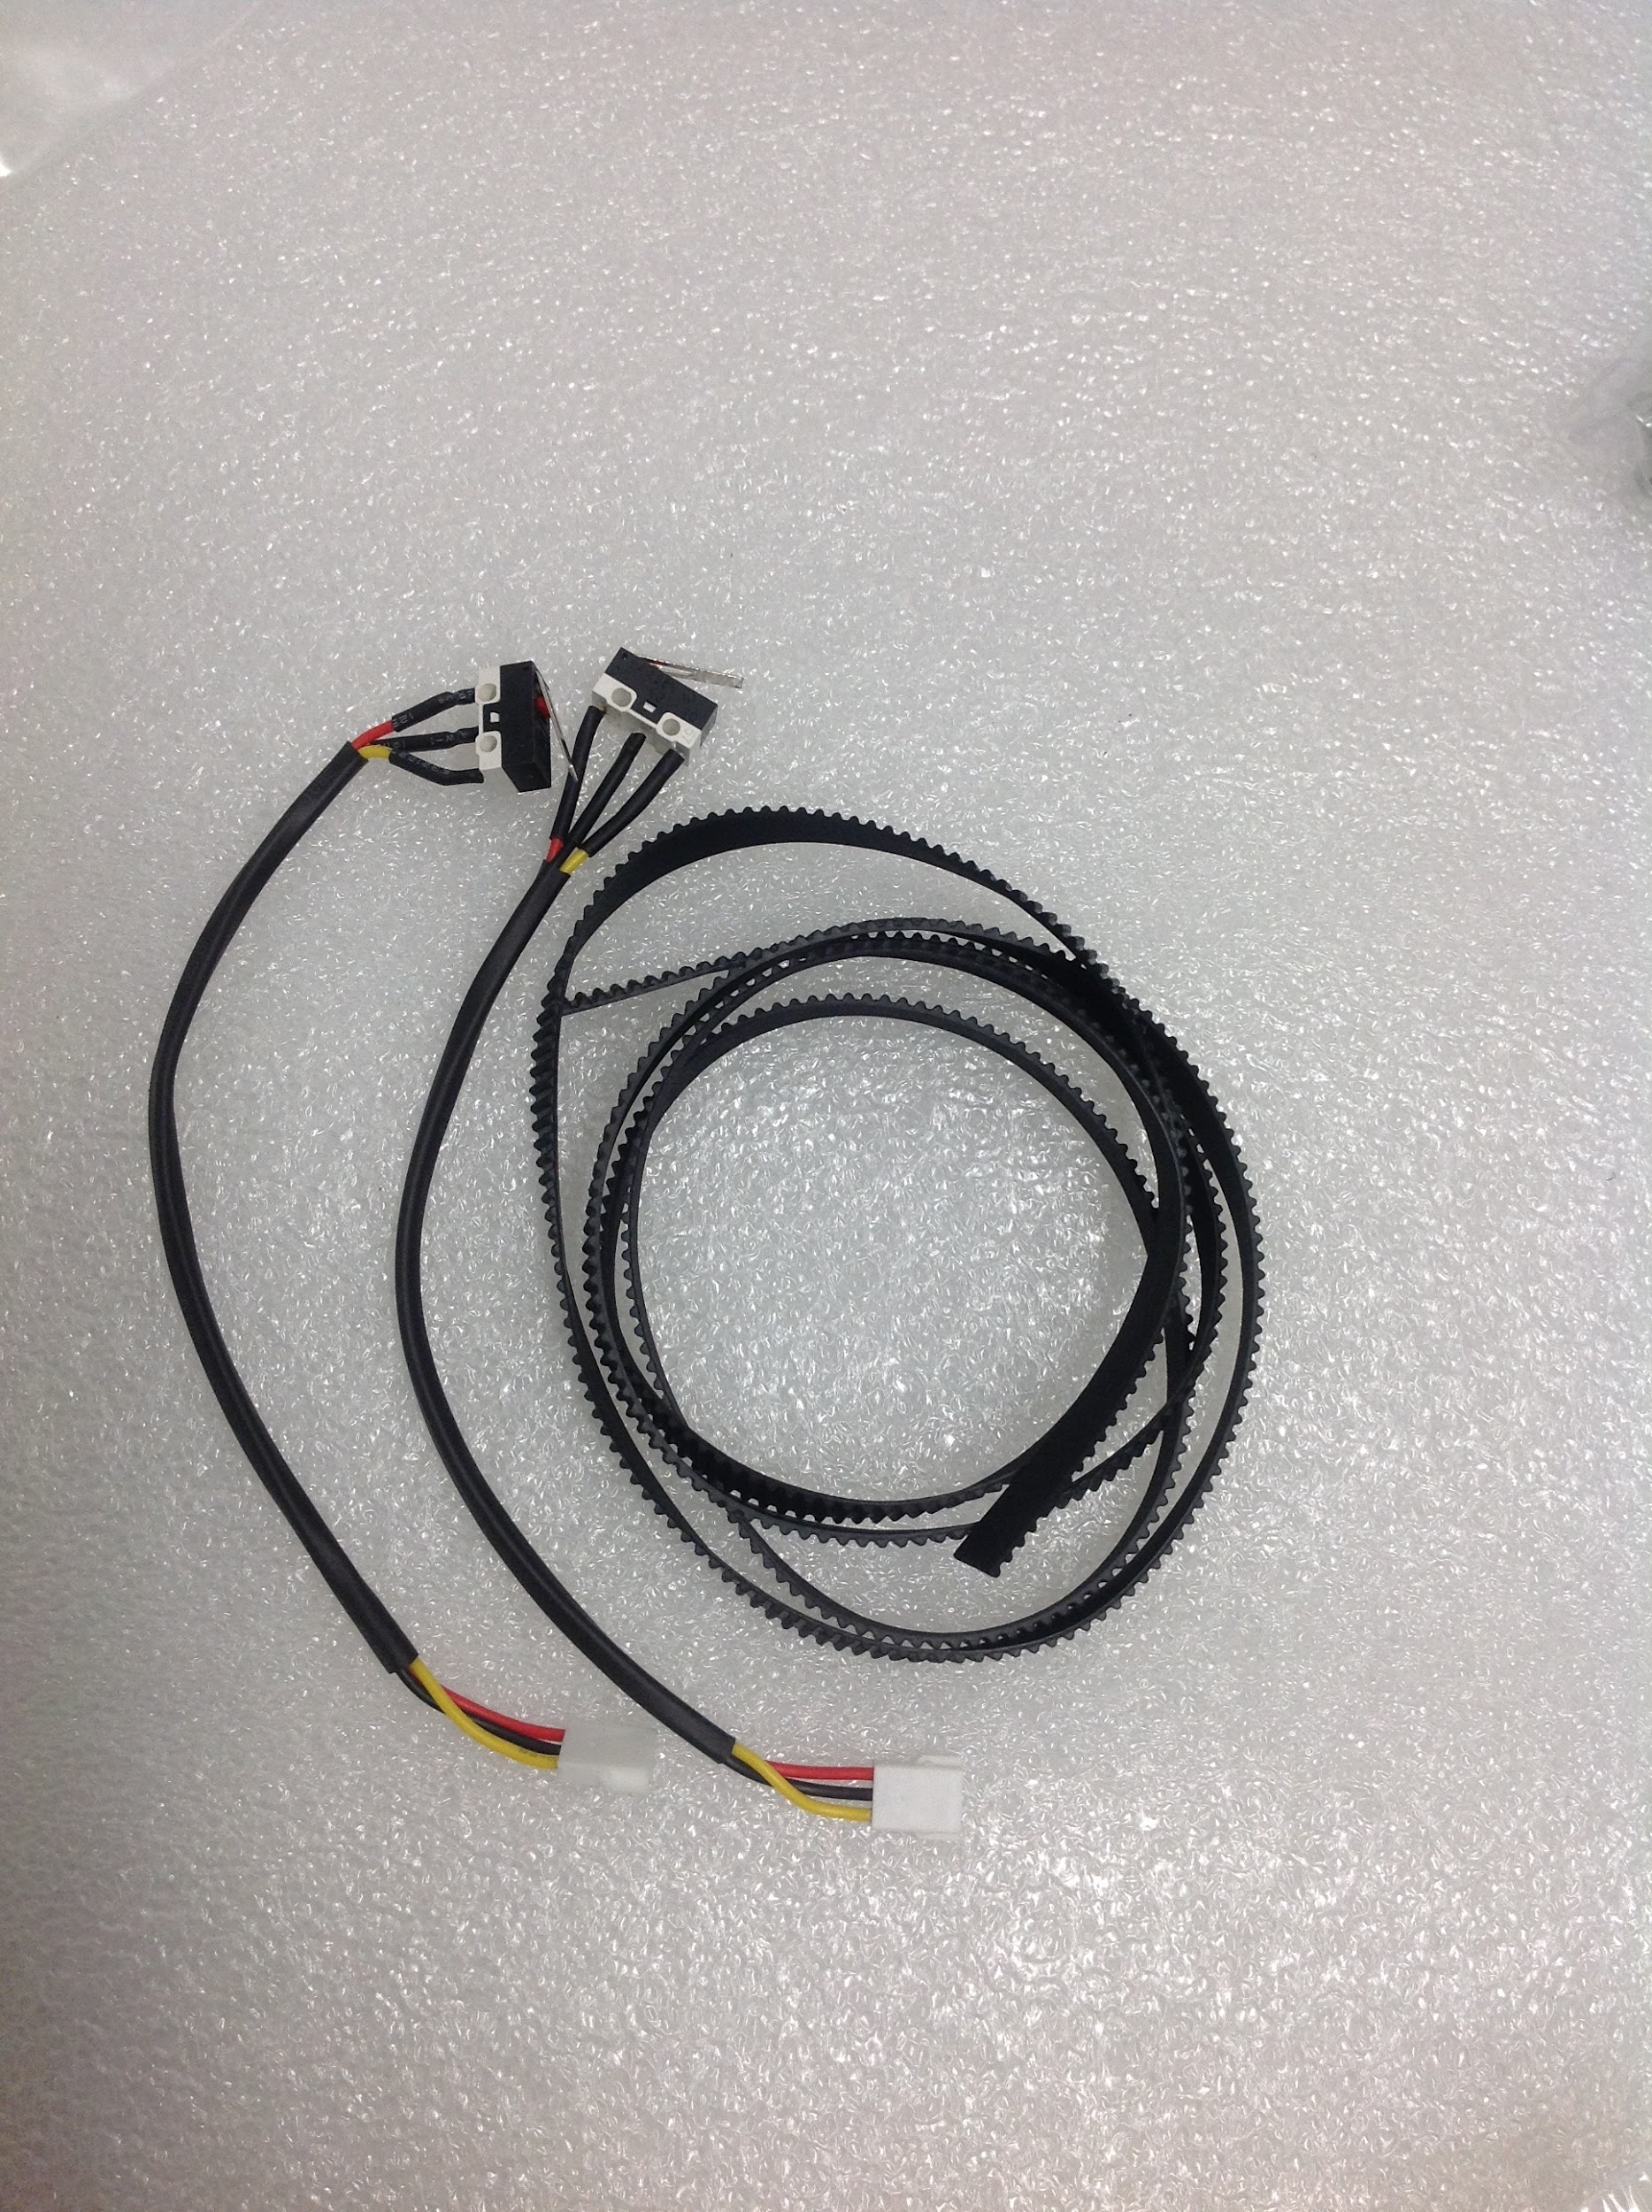

*8mm/10mm wrench with set of Allen Keys*

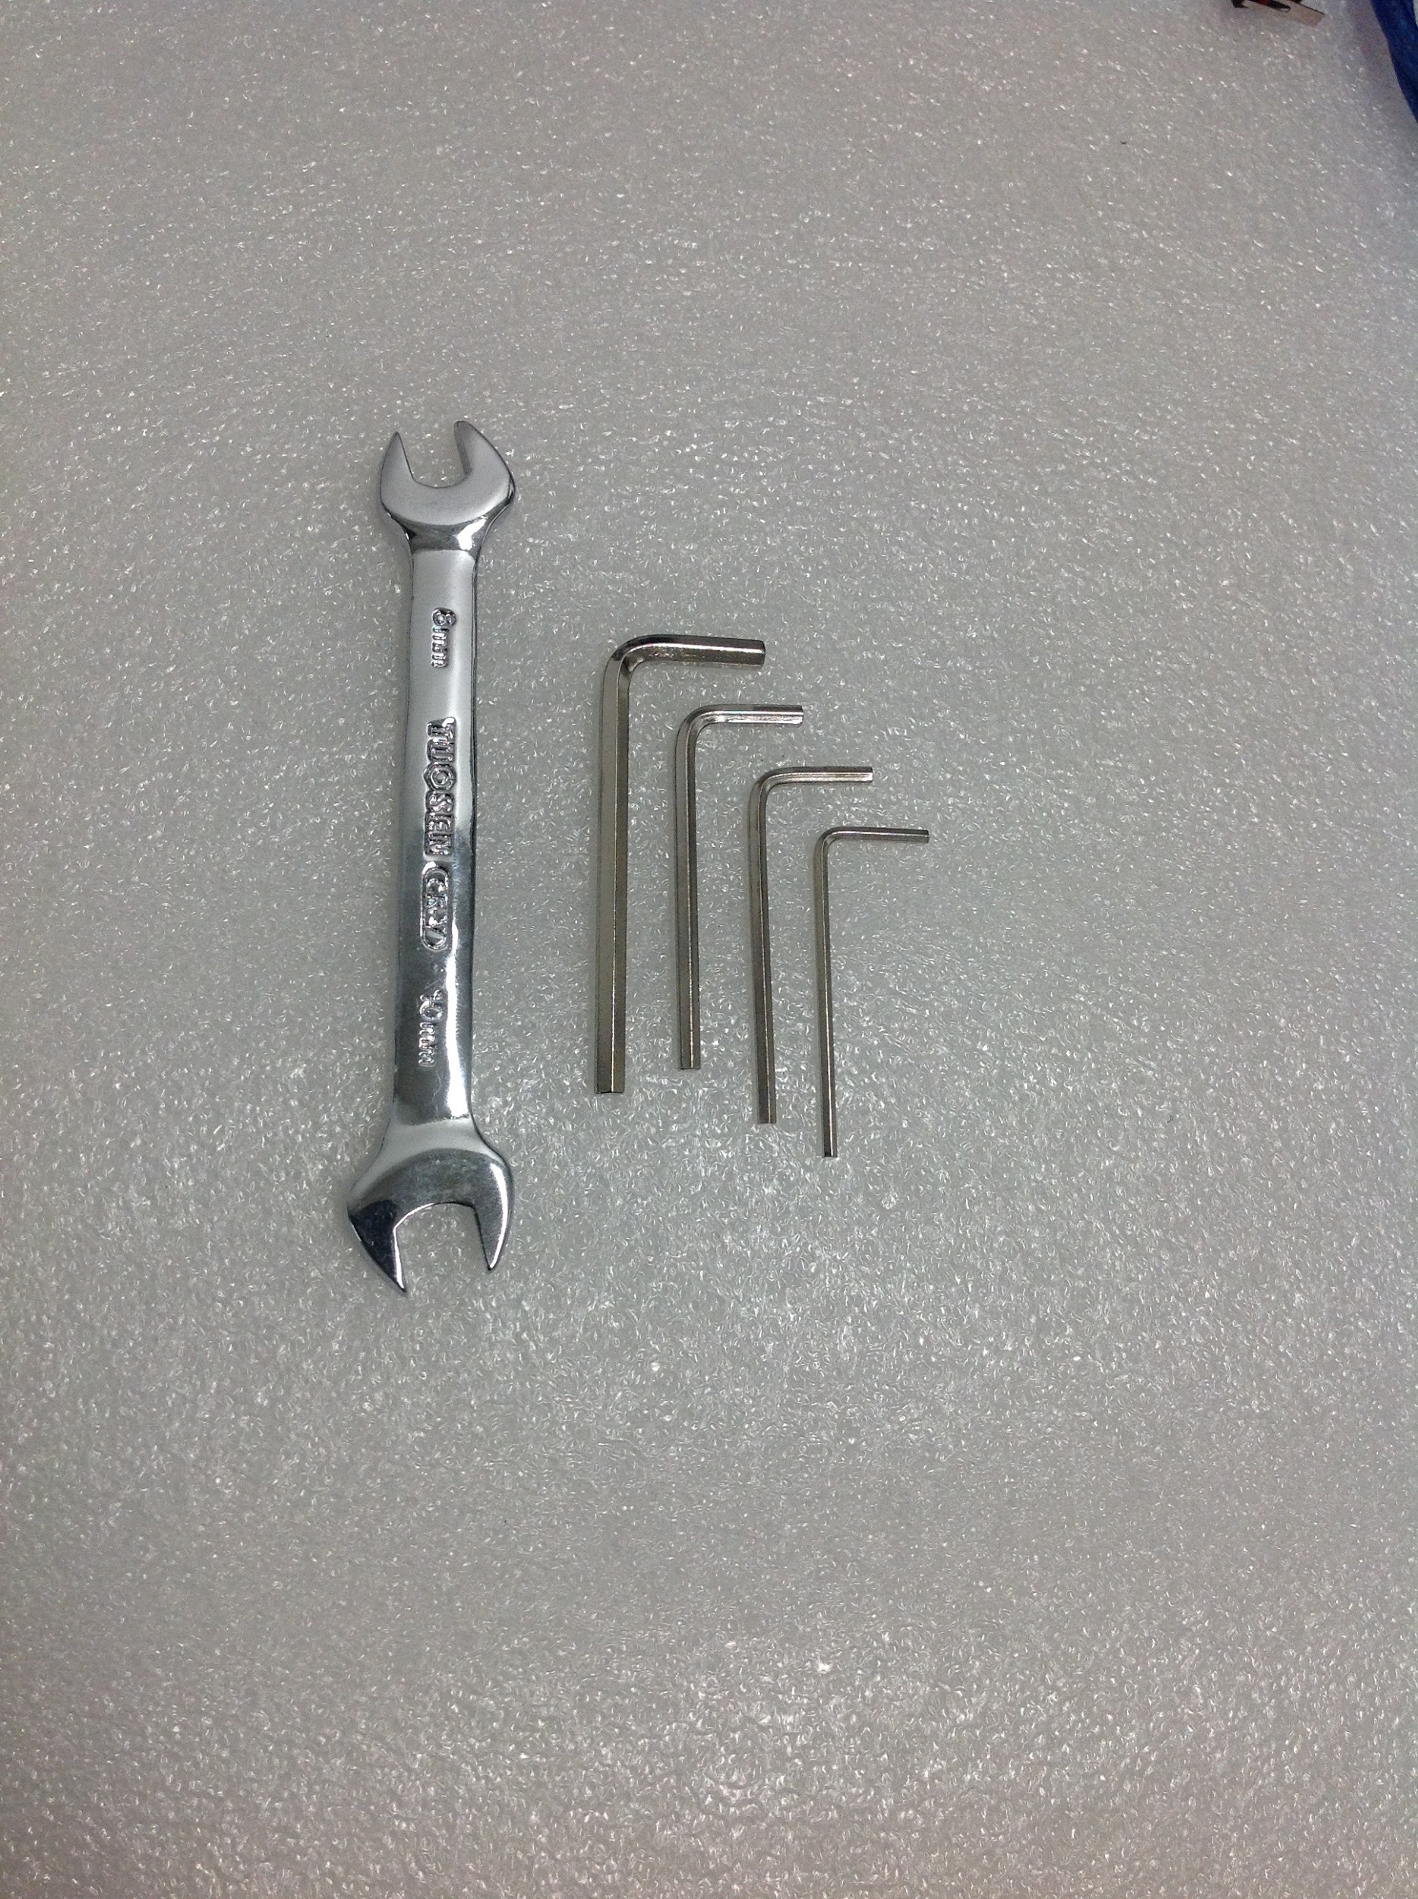

*3D printed hardware*

* *Bumpers*
* *Home switch plates*
* *X cable track brackets*
* *Z mount*

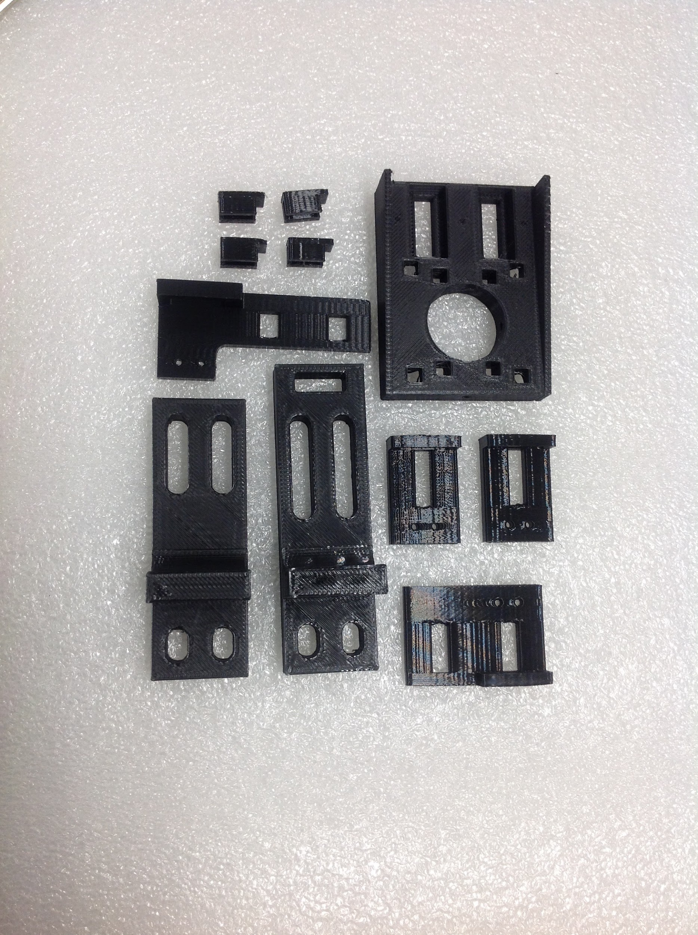

*Small tube of white lithium grease*

*\*\*white lithium grease is used to lubricate the motor threads and rods attached to the acrylic which moves the drop tip, only a small amount is needed*

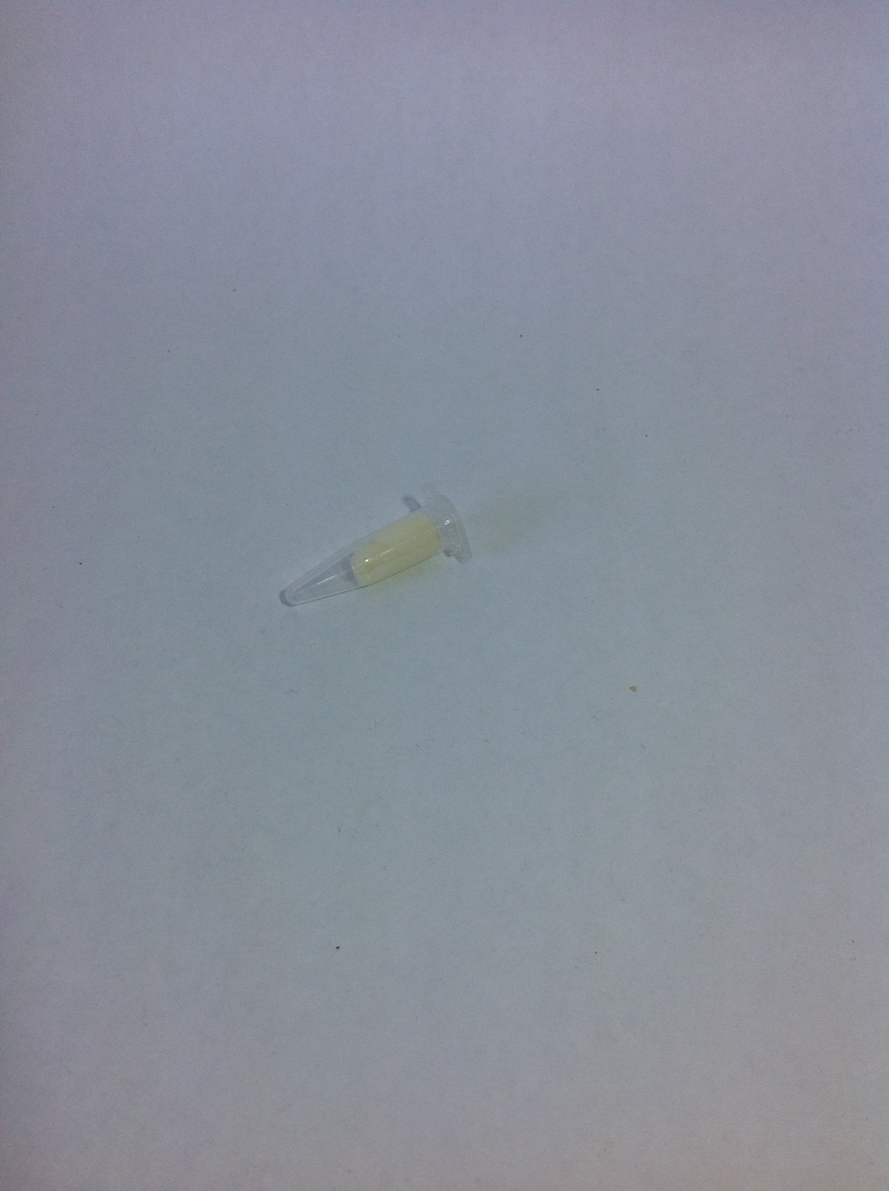

*Spare deck slot mount*

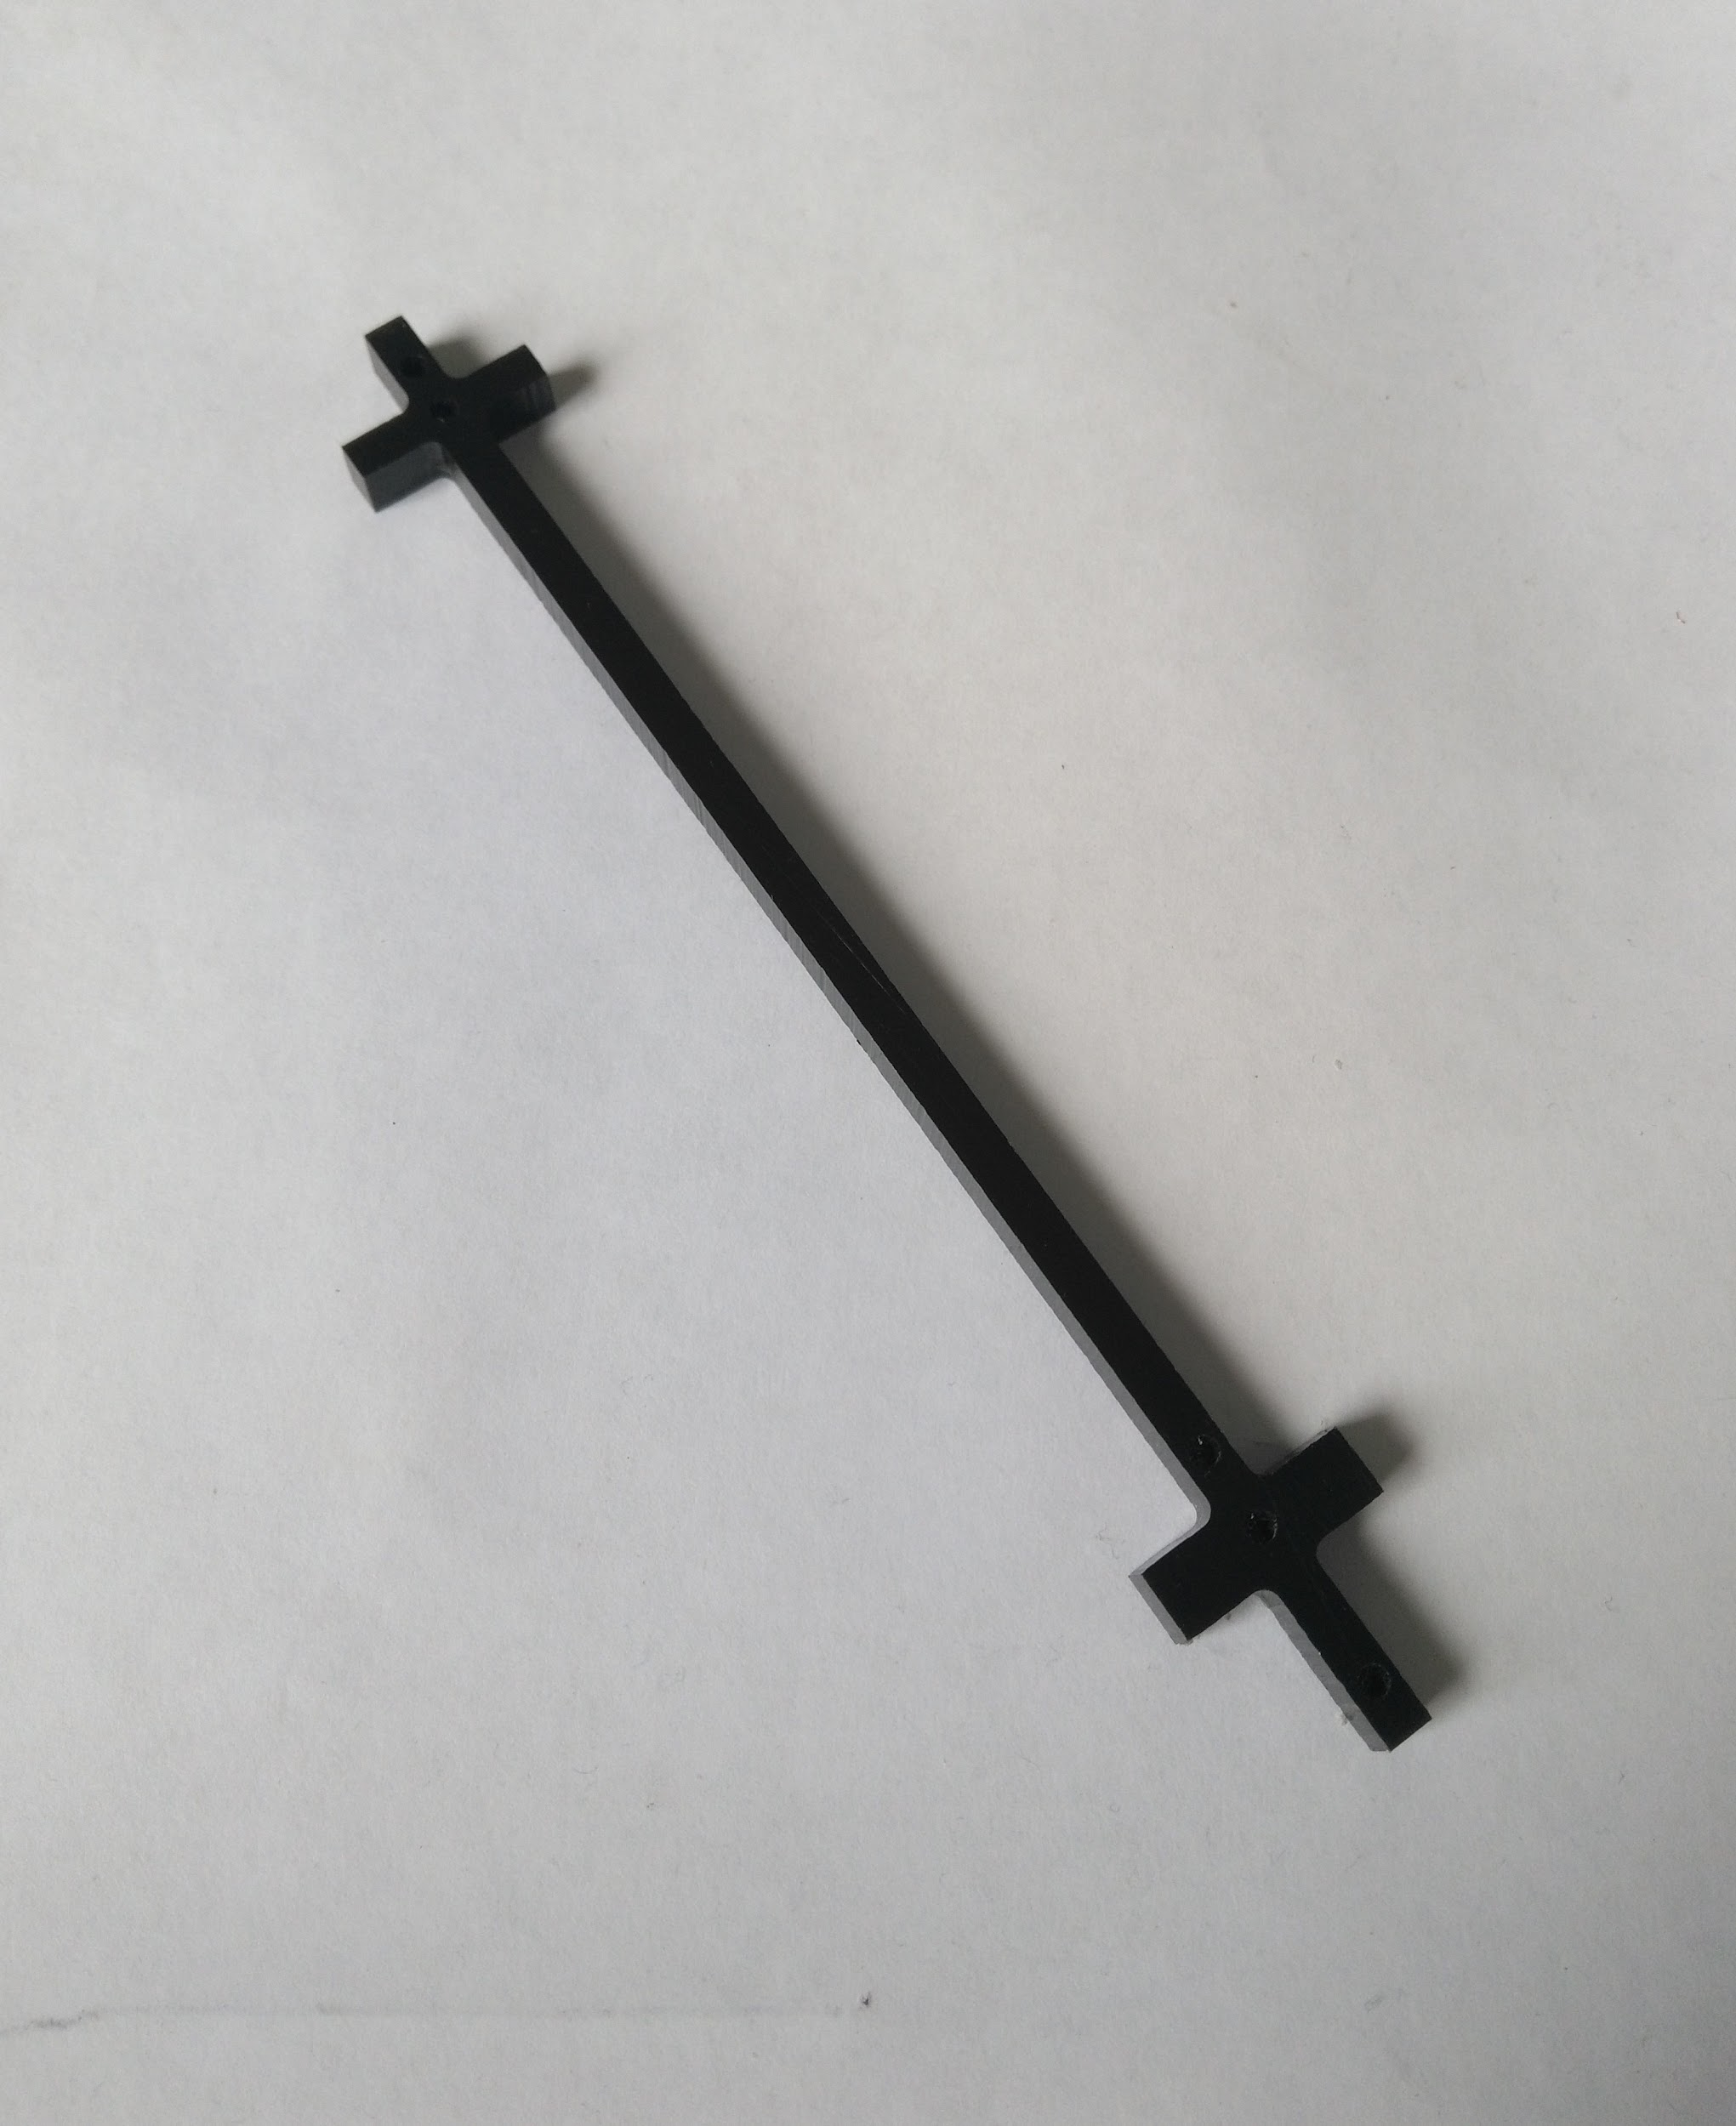

*A to B cable*

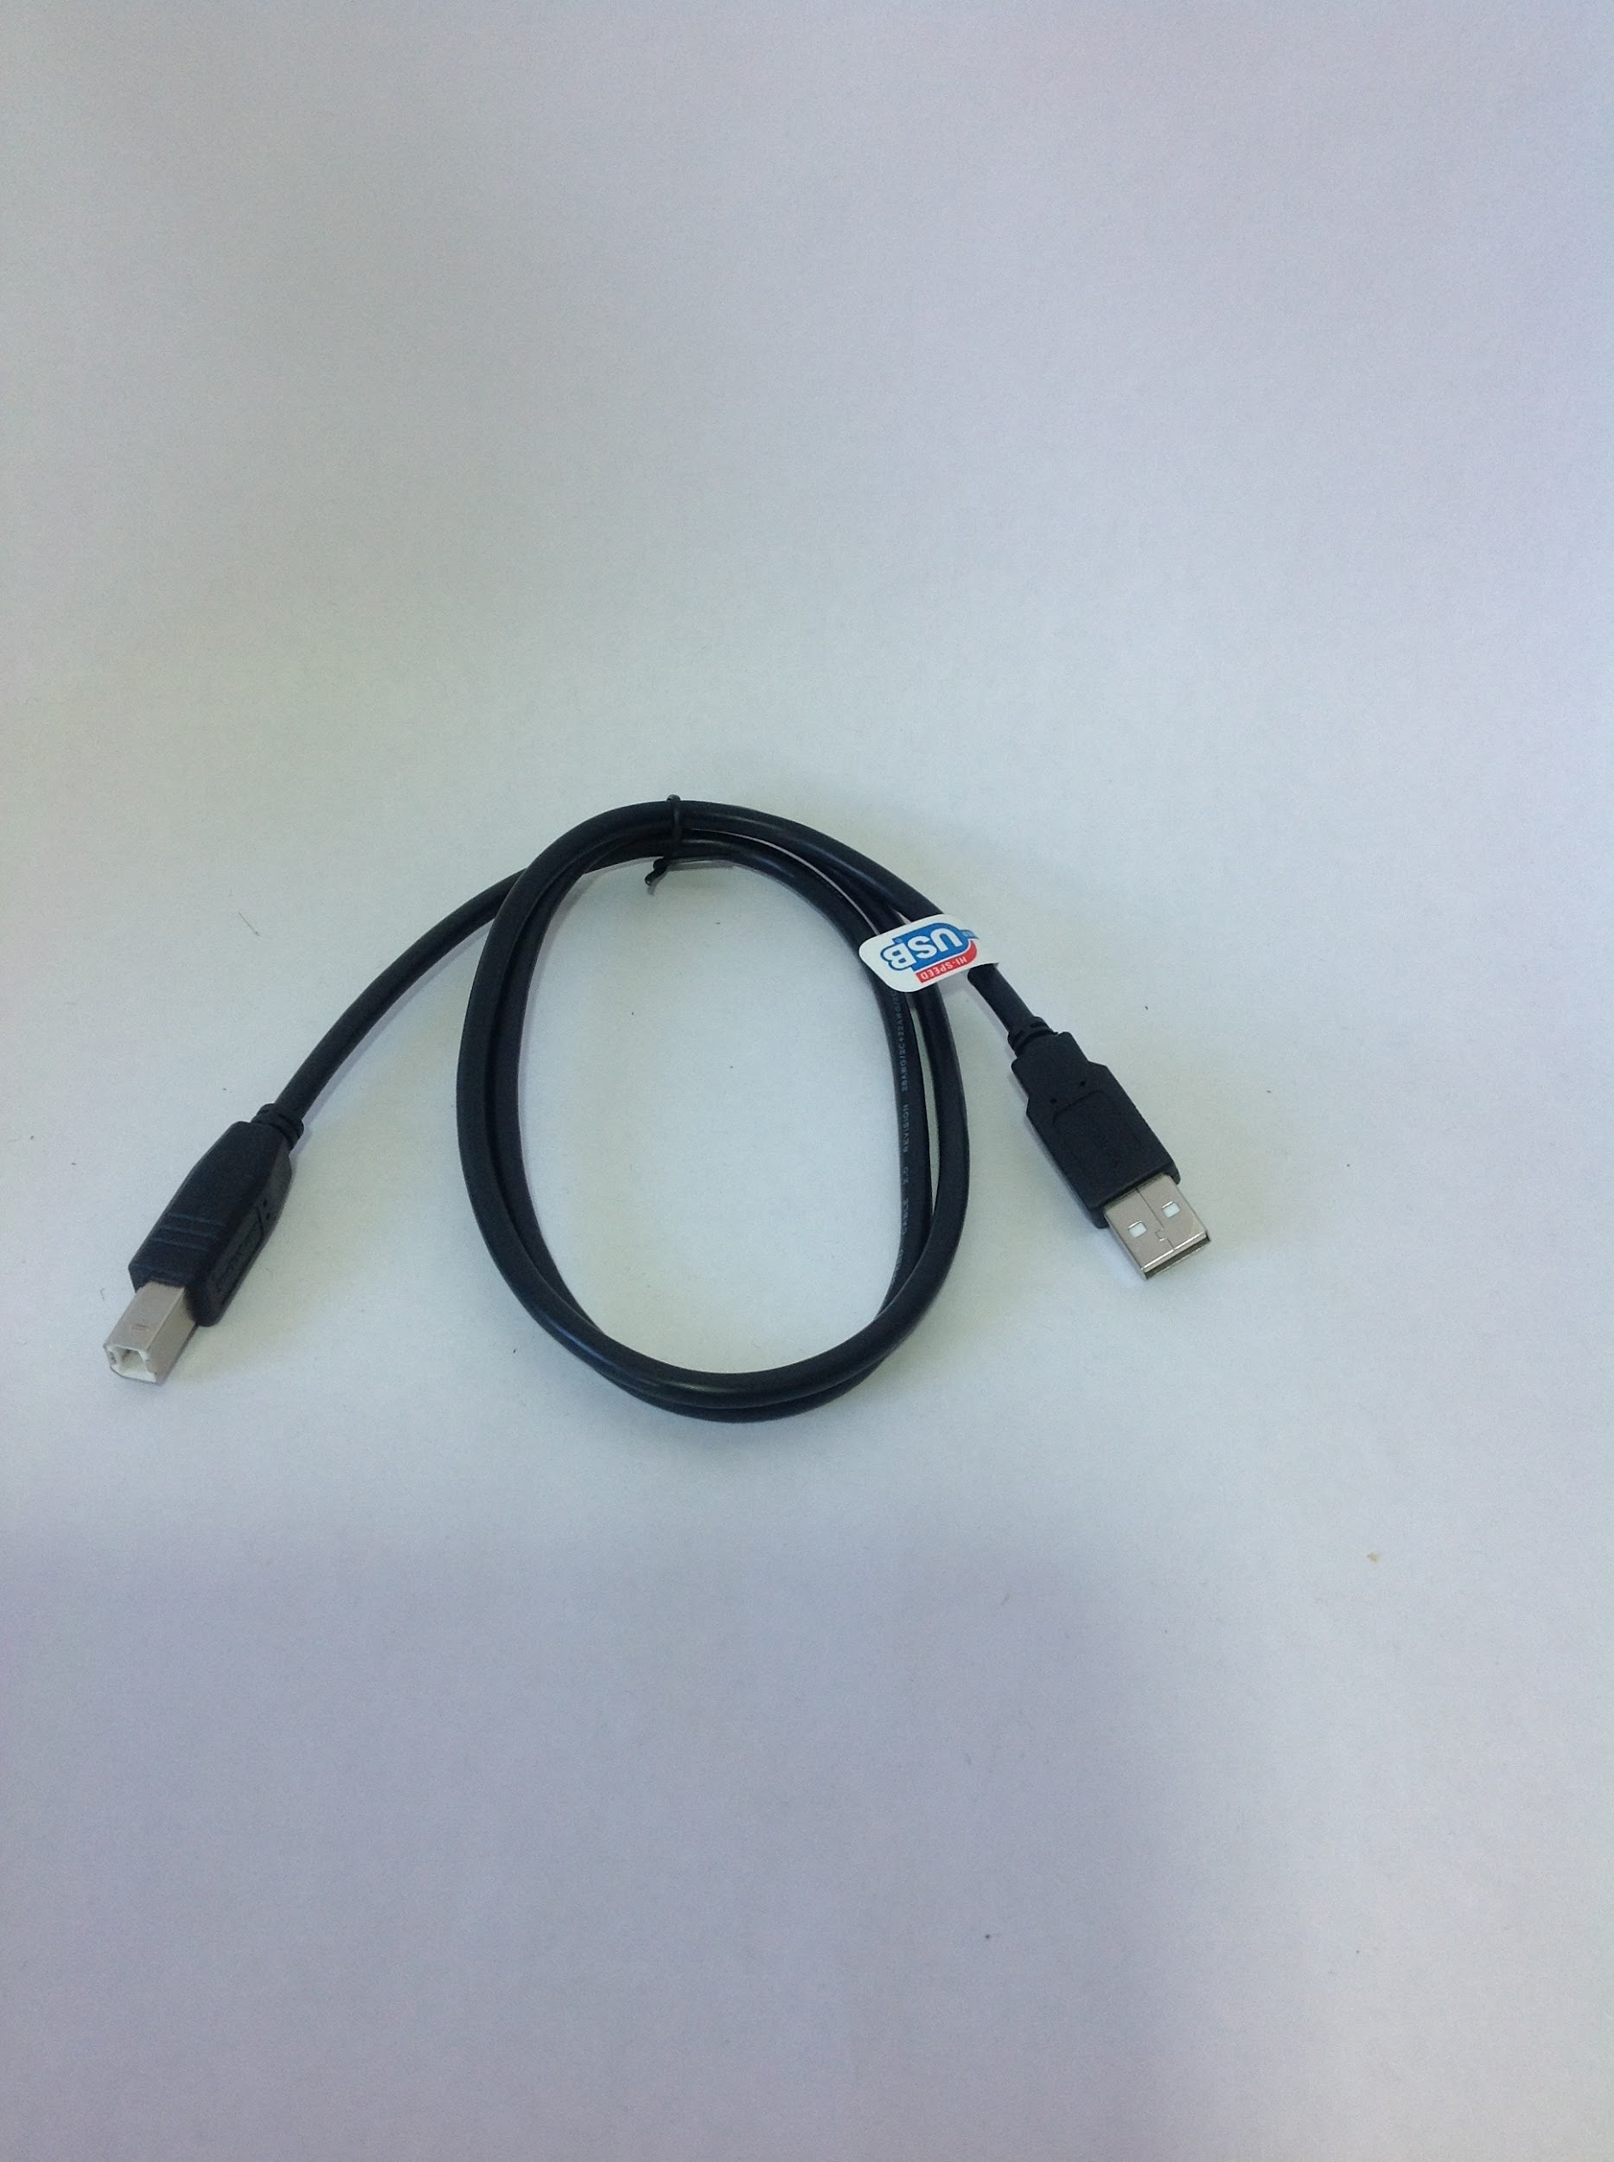

*Spare motor and switch cables*

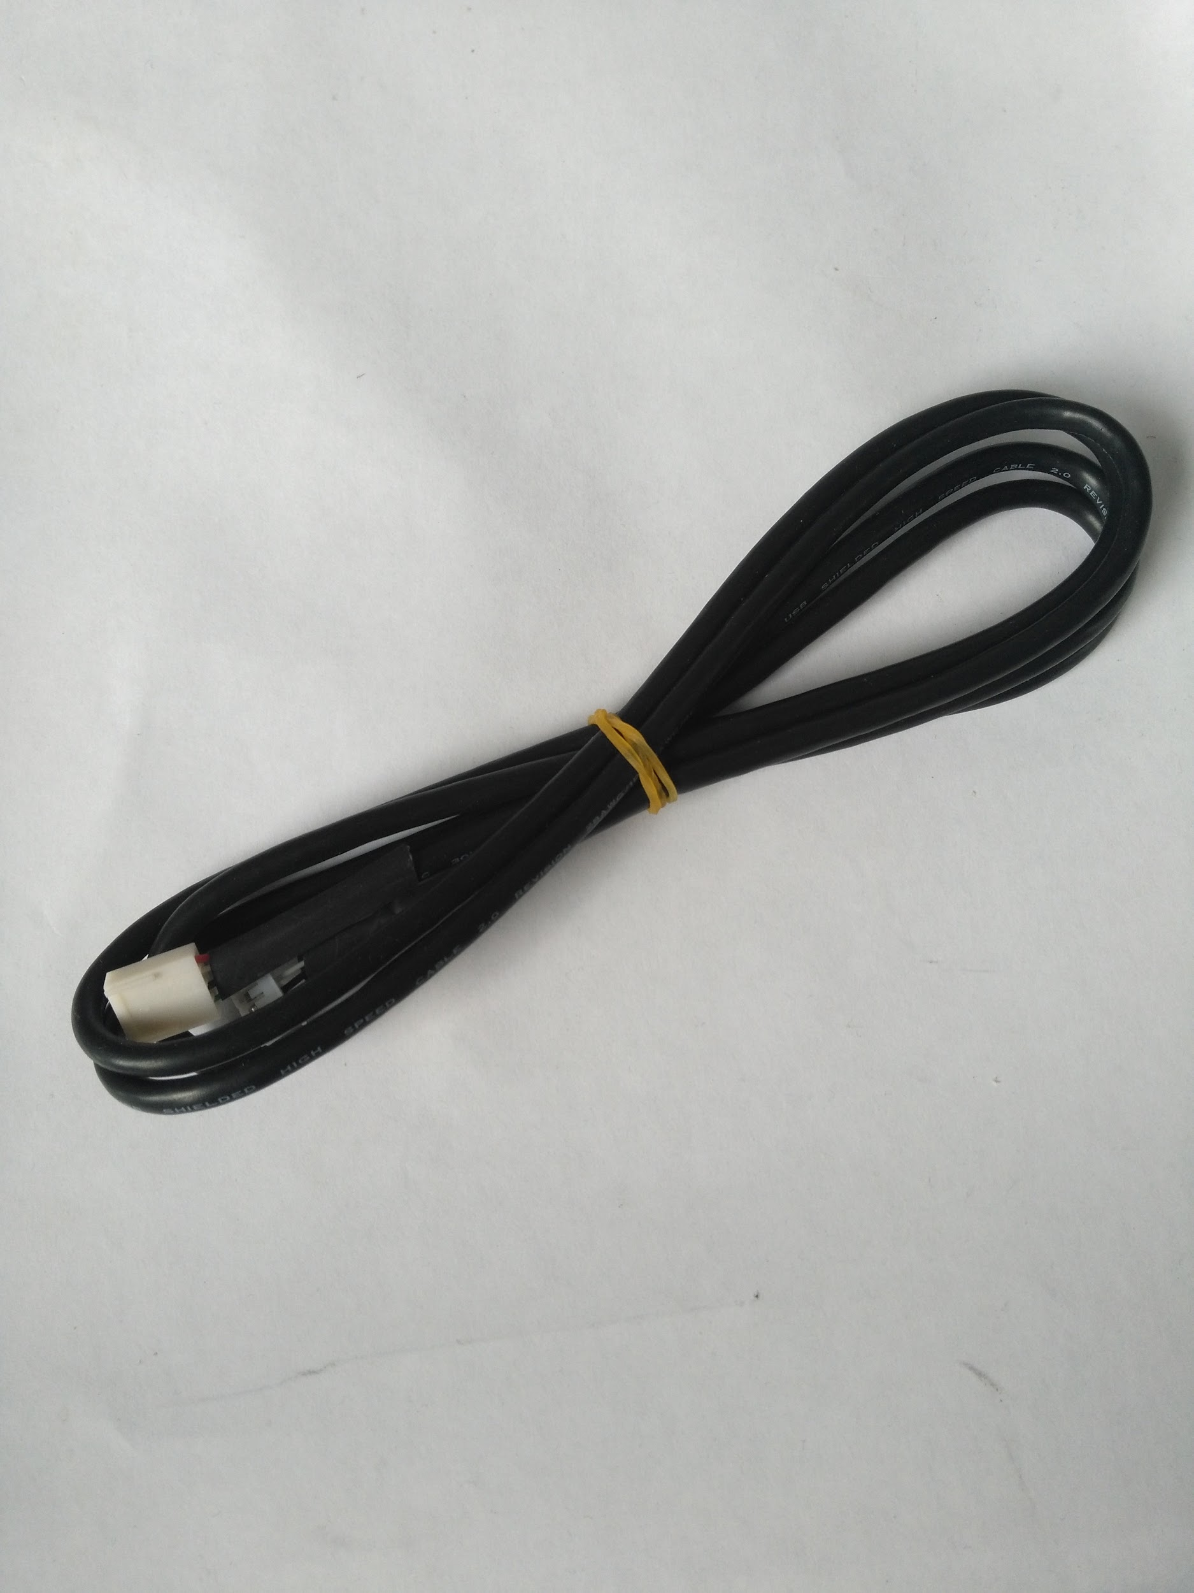

*Pipette hardware*

*\*\* The following hardware is included within the pipette box, pipettes will be removed from original boxes and mounted for easy installation.*

